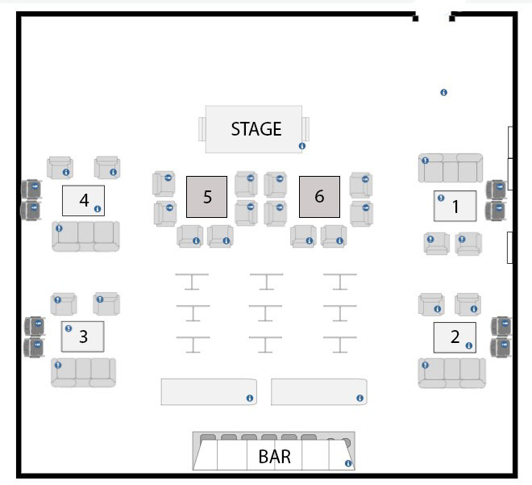
4 GENTS FLOOR PLAN

